Spinning Quadrants

All linear equations can be written in the form
$$y=mx+b$$
In this game, you will play in a group of 2 to 4 people.
When it is your turn
- You will spin both spinners
- Each player picks a quadrant starting with the player whose turn it is and moving clockwise around the table. Two players may not pick the same quadrant.
- Use the m and b to make an equation and graph it on the calculator.
- If the graph does go through the quadrant you picked, you get a point.
m b

-2

0

0

-1

1

2

-3

3

-2

0

0

-1

1

2

-3

3

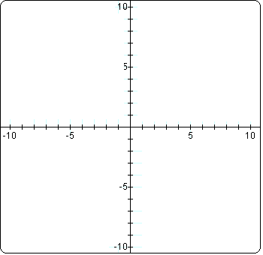y = x +
I
III
II
IV

