5B: Differential Equations
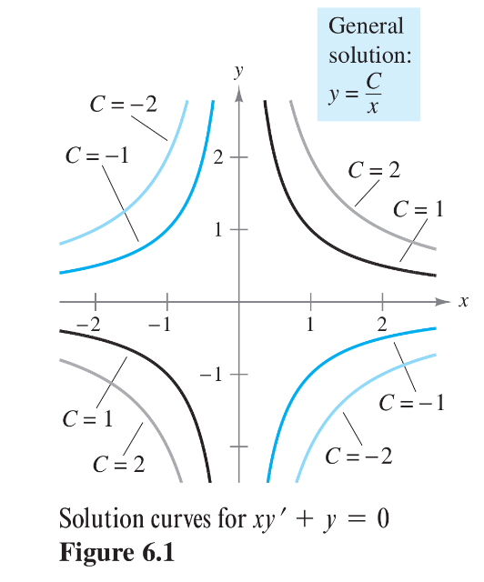
A differential equation (also known as a “diff EQ”, or an ODE for “ordinary differential Equation”) is a function of x, y, and derivatives of y. A differential equation has a General solution that represents a family of functions. We can use the general solution of a differential equation to find a particular solution using given initial conditions. The order of a differential equation is the highest order derivative in the equation.
Some differential equations have a Singular solution that cannot be written as a special case of the general solution. However, we will not study these in this class.
Since the general solution of a differential equation represents a countless number of functions that differ by a constant, we often want to consider the graphs of all these functions. To do this, we make a graph of all the solution curves like the one to the right that shows the graph of the solutions for different constants.

Try These:
- Show that $y=\frac{C}{x}$ is a general solution of $xy’+y=0$.
- For the differential equation $xy^{'}-3y=0$, verify that $y=Cx^{3}$ is a solution.
Now find the particular solution determined by the initial condition $y=2$ wen $x=-3$.

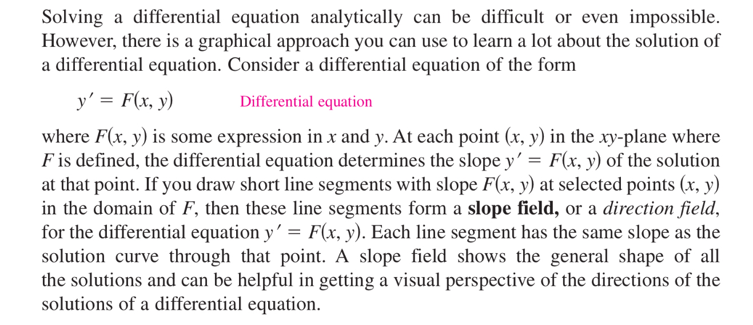
Slope Fields

Example

Exmaple
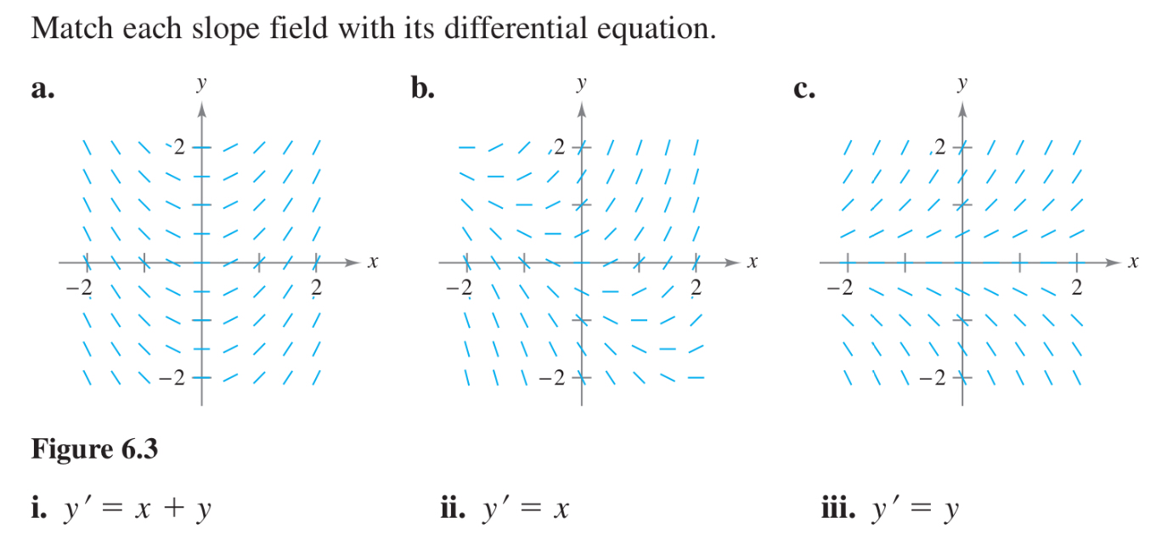

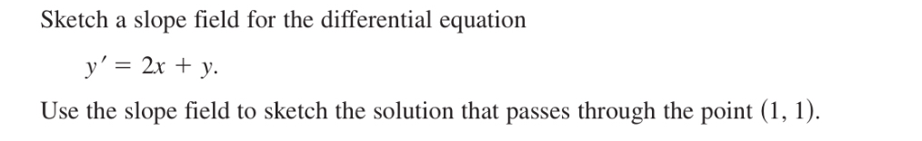
Example
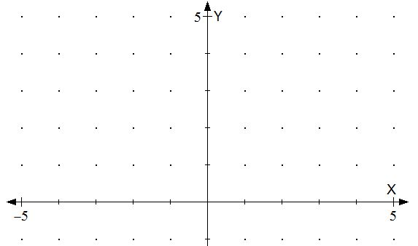

Seperable Differential Equations
A Separable Differential Equation is one in which the $x's$ and the $dx's$ can be separated from the $y's$ and $dy's$.
A first-order separable differential equation is one that has the form $\frac{dy}{dx}=f\left(x\right)g(y)$. In this equation, the right side is just a product of a function of $x$ and a different function of $y$.
When we are separating the variables, we must show this factorization, then we will treat $dy$ and $dx$ as infinitesimal variables that can be separated and moved about the equation.
Example
Solve the equation $\frac{dy}{dx}=\frac{x^{2}}{y^{2}}$ by separating the variables, then find the particular solution that satisfies the given initial conditions below.

- $y\left(0\right)=2$
- $y\left(0\right)=-2$
- $y(0)=0$

Example
Find the general and particular solution to the seperable differential equation $\frac{dy}{dx}=x^{2}y$ given the initial conditions given
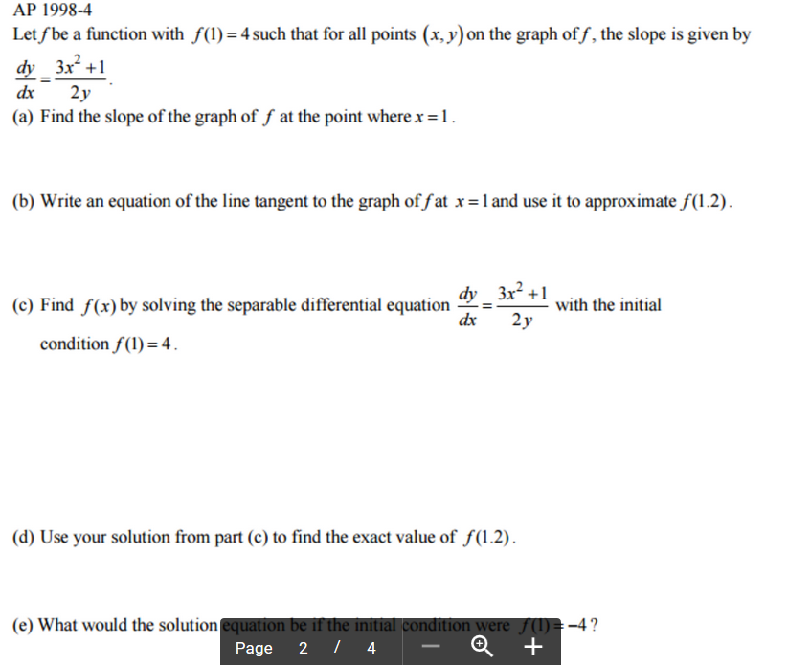
- $f\left(0\right)=1$
- $f\left(0\right)=-6$
AP Example

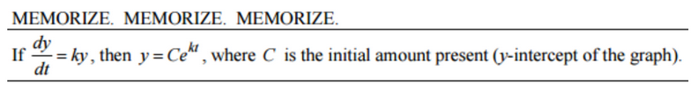
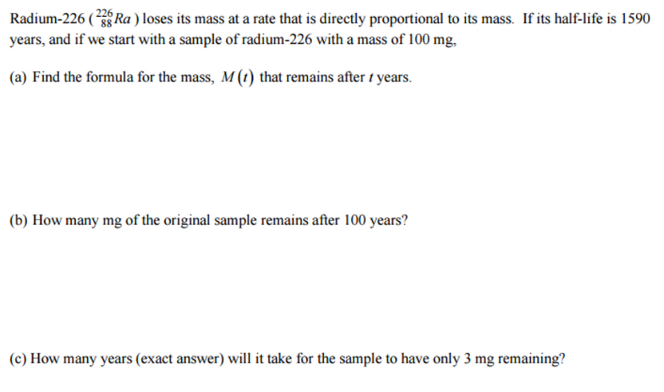
AP Example

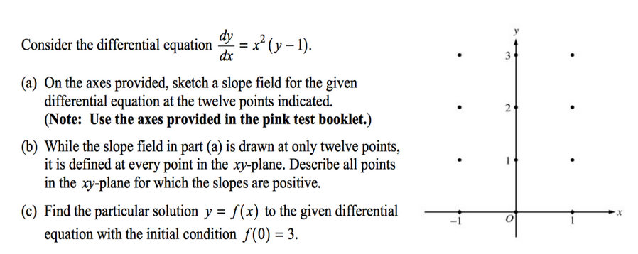
AP Example

