2C: Product and Quotient Rule
So, we have specific rules for the differentiation of power functions and some trig. functions. We also have general rules for the derivatives of constant multiples of functions and the sum or difference of some functions. Now we need to investigate the case where we have a product or quotient of two functions.

Product Rule
First, we need to figure out how to find the derivative of functions like $f\left(x\right)=x^{2}\sin{x}$.
Let’s make a Rule!
Ok, let’s write our derivative as
$$u^{'}=\lim_{Δx→0}{\frac{Δu-u}{Δx}}, and v^{'}=\lim_{Δx→0}{\frac{Δv-v}{Δx}}$$
Now let’s look at the derivative $\frac{d}{dx}\left[uv\right]$ for functions $u\left(x\right)$ and $v\left(x\right)$.
$${\left(uv\right)}^{'}=\lim_{Δx→0}{\frac{ΔuΔv-uv}{Δx}}$$
Now, I wish this fraction said $\frac{Δu-u}{Δx}$ or $\frac{Δv-v}{Δx}$ so we could write it as $u^{'}$ and $v'$. Let’s get creative…
General Rule 4: Product Rule
If $u$ and $v$ are differentiable functions, then $uv$ is a differentiable function and
$$\frac{d}{dx}\left[uv\right]=u^{'}v+uv'$$
That is, the derivative of a product is equal to $"The derivative of the 1st times the 2nd, plus the 1st times the derivative of the 2nd."$
$${\left(uv\right)}^{'}=\lim_{Δx→0}{\frac{ΔuΔv-uv}{Δx}}=\lim_{Δx→0}{\frac{ΔuΔv-uΔv+uΔv-uv}{Δx}}=\lim_{Δx→0}{\frac{\left(Δu-u\right)Δv+u\left(Δv-v\right)}{Δx}} \\ \lim_{Δx→0}{\frac{\left(Δu-u\right)}{Δx}Δv+u\frac{(Δv-v)}{Δx}}=u'v+uv'$$

Examples Find the derivative of the function.
- $f\left(x\right)=x^{3}(5x^{5}-x^{2})$
- $g\left(x\right)=5x^{3}\cos{x}$

- $h\left(x\right)=2x\cos{x}-2\sin{x}$

Quotient Rule
If multiplication gets its own rule, division should get one too. Let’s find a rule for division quotients.
So, we start with two differentiable functions $u(x)$ and $v(x)$.
General Rule 5: Quotient Rule
If $u$ and $v$ are differential functions, so is ${\left(\frac{u}{v}\right)}^{'}$, and
$${\left(\frac{u}{v}\right)}^{'}=\frac{u^{'}v-uv^{'}}{v^{2}}$$That is, the derivative of a quotient is equal to
$$"The derivative of the top times the botom,minus times the top the derivative of the bottom, \\ all over the bottom squared."$$
$${\left(\frac{u}{v}\right)}^{'}=\lim_{Δx→0}{\frac{1}{Δx}\left(\left(\frac{Δu}{Δv}\right)-\left(\frac{u}{v}\right)\right)}=\lim_{Δx→0}{\frac{1}{Δx}\left(\frac{Δuv-uΔv}{Δv⋅v}\right)}=\lim_{Δx→0}{\frac{1}{Δx}\left(\frac{Δuv-uv-uΔv+uv}{Δv⋅v}\right)} \\ =\lim_{Δx→0}{\frac{1}{Δx}\left(\frac{\left(Δu-u\right)v-u\left(Δv-v\right)}{Δv⋅v}\right)}=\lim_{Δx→0}\left(\frac{\frac{\left(Δu-u\right)}{Δx}v-u\frac{\left(Δv-v\right)}{Δx}}{Δv⋅v}\right)=\frac{u^{'}v-uv^{'}}{v^{2}}$$

Examples Use the quotient rule to find these derivatives.
- $\frac{d}{dx}\left[\frac{4x^{2}-1}{x+3}\right]$
- $\frac{d}{dx}\left[\frac{\sin{x}}{\cos{x}}\right]$

Putting it all together… Combo time!
Now we have two very useful tools, let’s put them together to find the derivative of some more complex functions.
Try it! Find the derivative of the following functions.
$$y=\frac{x\sin{x}}{x+1}$$ | $$g\left(x\right)=\left(\frac{x}{x+1}\right)(\sin{x})$$
How about some more trig. functions…
$\frac{d}{dθ}\tan{θ}=\frac{d}{dθ}\left[\frac{\sin{θ}}{\cos{θ}}\right]$ | $\frac{d}{dθ}\cot{θ}=\frac{d}{dθ}\left[\frac{\cos{θ}}{\sin{θ}}\right]$
$\frac{d}{dθ}\csc{θ}=\frac{d}{dθ}\left[\frac{1}{\sin{θ}}\right]$ | $\frac{d}{dθ}\sec{θ}=\frac{d}{dθ}\left[\frac{1}{\cos{θ}}\right]$
Here’s how the AP test will use these rules:

Higher Derivatives
Now that we have more ways to find derivatives, we can start to find higher derivatives. This just means we will take the derivative of the derivative.
Example Find the second derivative of $s\left(t\right)=-.81t^{2}+2$ which is the position function for a falling object on the moon.

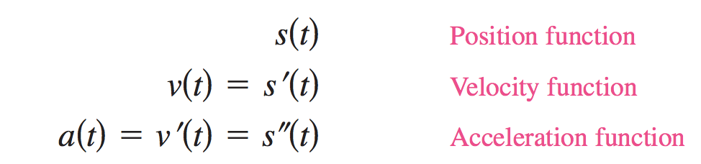
When working with physics applications, we have a very important relationship that we will work more with later:
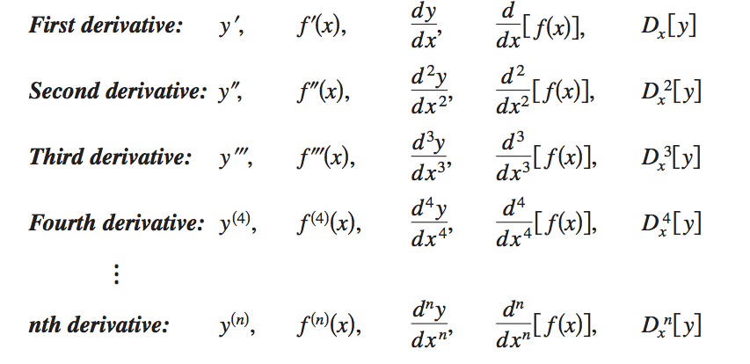
In General, this table gives us the notation for higher derivatives:

