Assignment

4.2

**In** Exercises 1–3, graph and its image after a reflection in the given line.

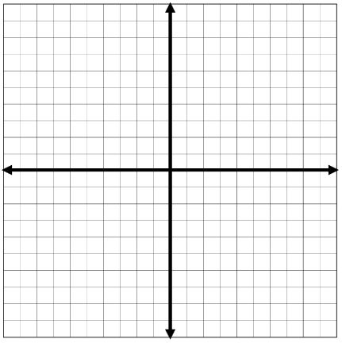 1.  2. 

 3. 

**In Exercises 4 and 5, graph the polygon and its image after a reflection in the given line.**

4.  5. 

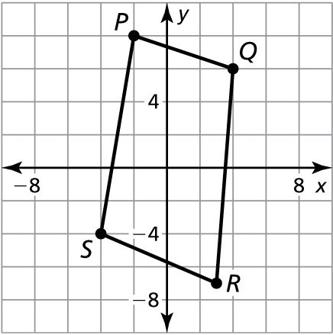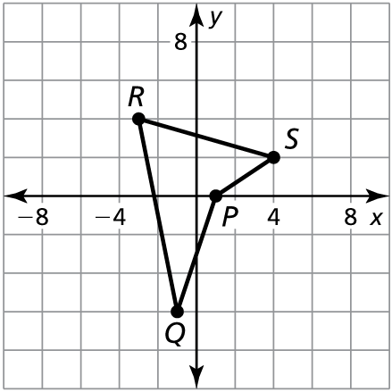

3b. 4b.

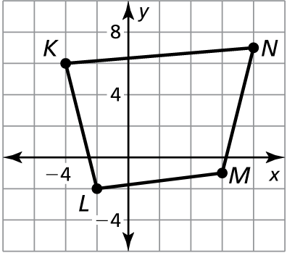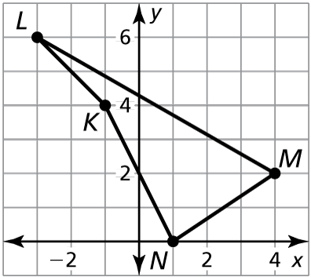

In Exercises 6 and 7, graph with vertices and its image after the glide reflection.

 6. **Translation:**  7. **Translation:**   
**Reflection:** in the *x*-axis **Reflection:** in the line 



In Exercises 8 and 9, determine the number of lines of symmetry for the figure.

8. 9.

|  |  |
| --- | --- |
|  |  |
|  | |